Questions

In the investigation, assume all constants of integration are zero and each integration and differentiation is done with respect to the variable x.

Which graph …

Statement | Graph number
is the integral of -1/x²?
is the gradient function of 1/x?
is the integral of sin(x)?
is the gradient function of cos(x)?
is the gradient function of -ln(x)?
is the integral of sin($\frac{1}{2}$x)?
is the gradient function of sin²(x)?
is the integral of e^{x}?
is the gradient function of sin(x) + 2x?
is the integral of e^{2x}?
is the gradient function of e^{2x}?
is the integral of 1/x?
is the gradient function of tan(x)?
is the integral of sec(x)tan(x)?
is the integral of cos(x)?
is the gradient function of -ln(cos(x))?

Graphs

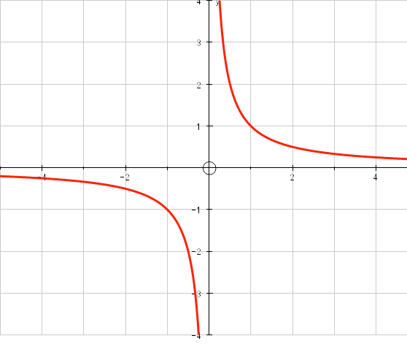
A.

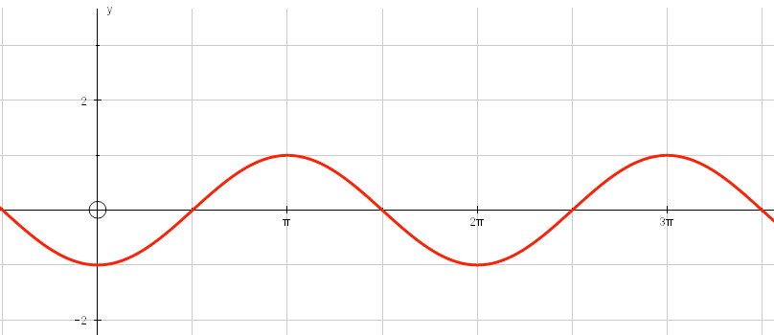
B.

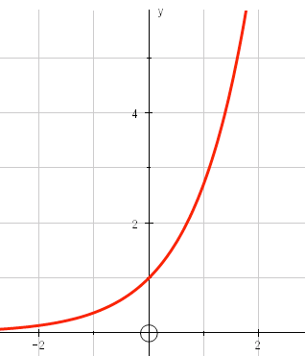
C.

D.
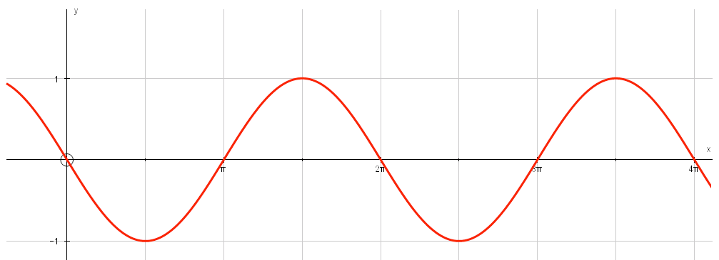
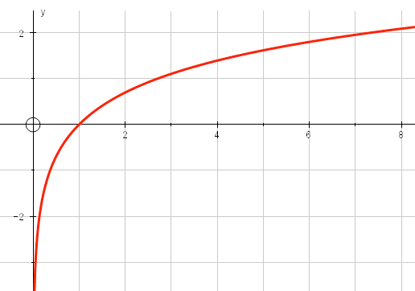
E.

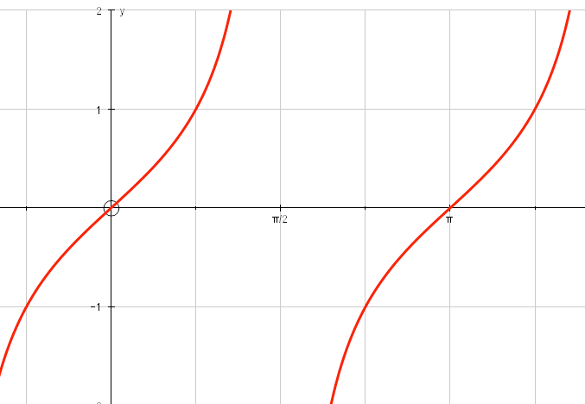
F.

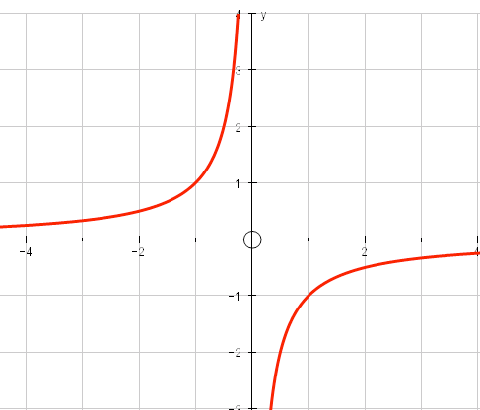
G.

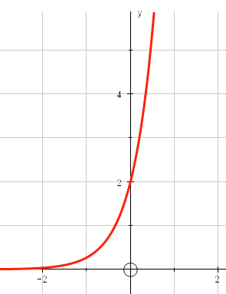
H.

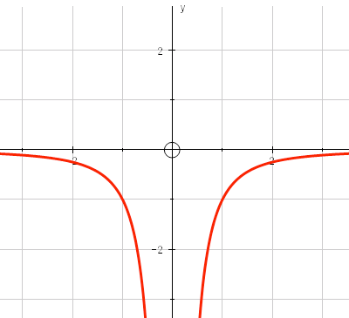
I.

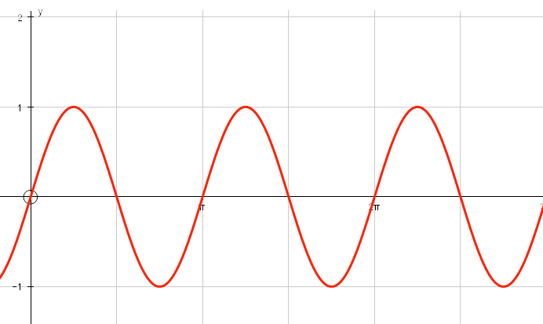
J.

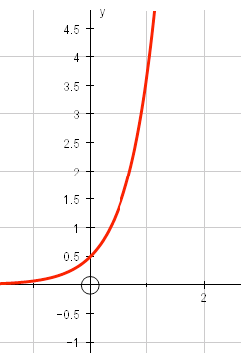
K.

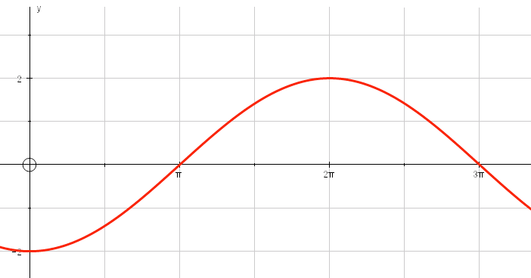
L.

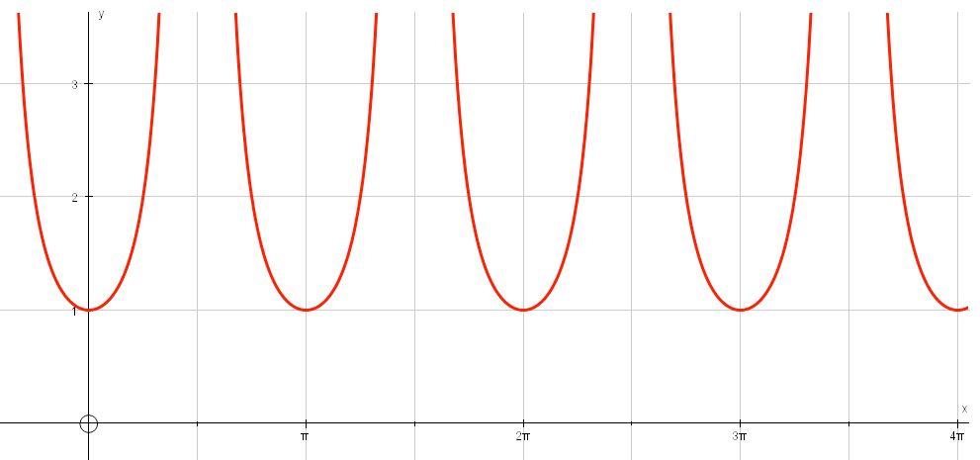
M.

N.
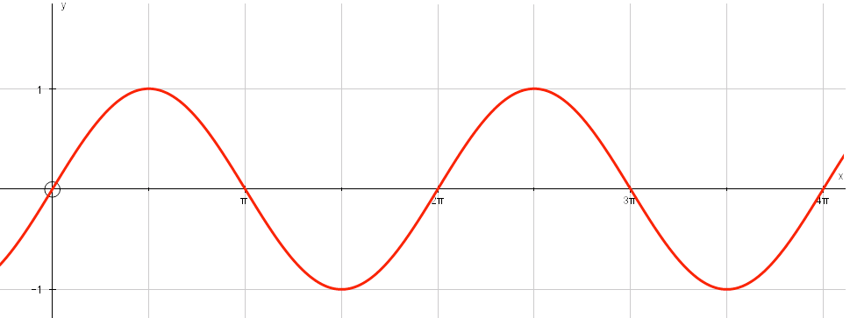
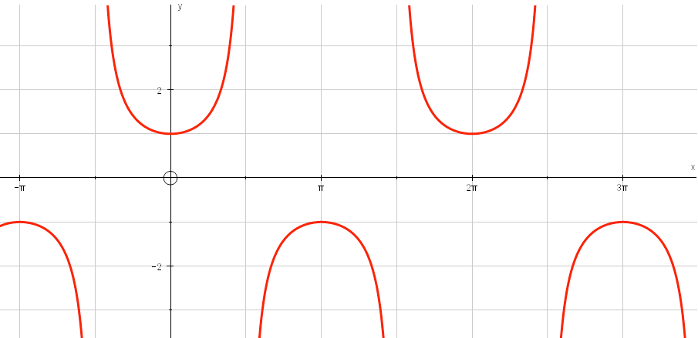
O.

P.
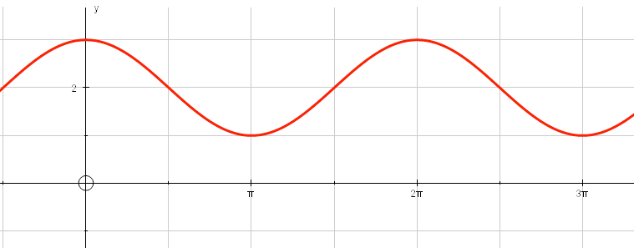

Solutions

Statement | Graph number
is the integral of -1/x²? | A
has the gradient function of 1/x? | I
is the integral of sin(x)? | B
is the gradient function of cos(x)? | D
is the gradient function of -ln(x)? | G
is the integral of sin($\frac{1}{2}$x)? | L
is the gradient function of sin²(x)? | J
is the integral of e^{x}? | C
is the gradient function of sin(x) + 2x? | P
is the integral of e^{2x}? | K
is the gradient function of e^{2x}? | H
is the integral of 1/x? | E
is the gradient function of tan(x)? | M
is the integral of sec(x)tan(x)? | O
is the integral of cos(x)? | N
is the gradient function of -ln(cos(x))? | F

